OPHS Laptop Basics
Quick Guide for Teachers, Students, and Parents

Laptop Information
- MacBook Air, 2020
- Contact Mrs. McPhail judy.mcphail@nkcschools.org or Angela Van Batavia angela.vanbatavia@nkcschools.org with issues
- Charge every night
- Restart once a week
- Password can only be changed on NKCSD sites

Downloading Apps to your MacBook Air
- You will download apps to put on your MacBook from here. To get to Self-Service, go to Launchpad, two-finger swipe to the second page. Click Self-Service then login with your Student ID and password.
  - Microsoft Apps: Students will need (at a minimum) Microsoft Excel, Microsoft Outlook, Microsoft PowerPoint, Microsoft Teams, and Microsoft Word. Click on each of these to install them as apps to your laptop.
    - Once students install Microsoft Outlook, they will need to sign in and check their account at least twice a day.
    - Students’ email address is their StudentNumber@nkcschools.org
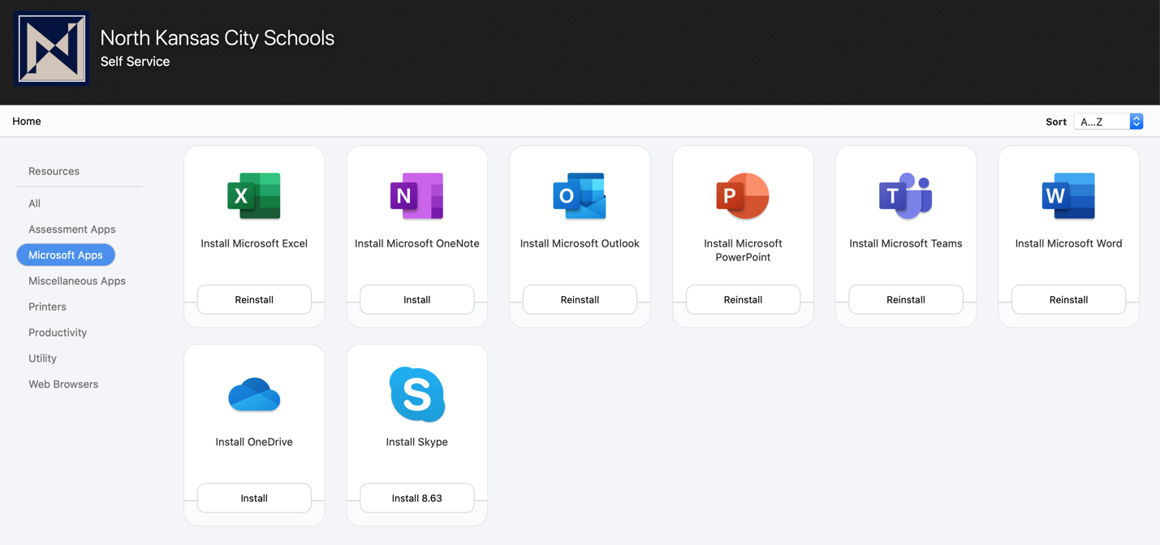

  - Productivity Apps: Students will need:
    - Box. However, before the Box app is installed, students must first install the web version on Box, located here. After students install the web version, then they should install the Box app in the Productivity section.
    - Box is an online storage system that can be moved to students’ desktop.
    - Here is a quick video to guide with Box.

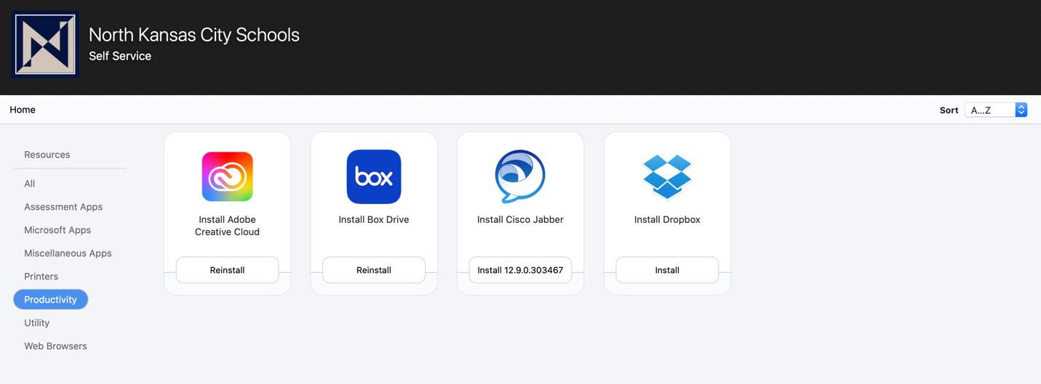

  - Web Browsers: Students should download Google Chrome and use this browser while using Canvas.
    - Safari is automatically on the MacBook Air. 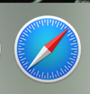

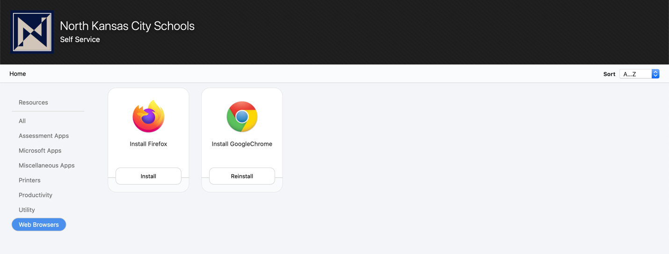

  - Printers: If a student is an taking in-person classes, they may need periodic printing capabilities. To print at school, they will need to install the Konica Printer.

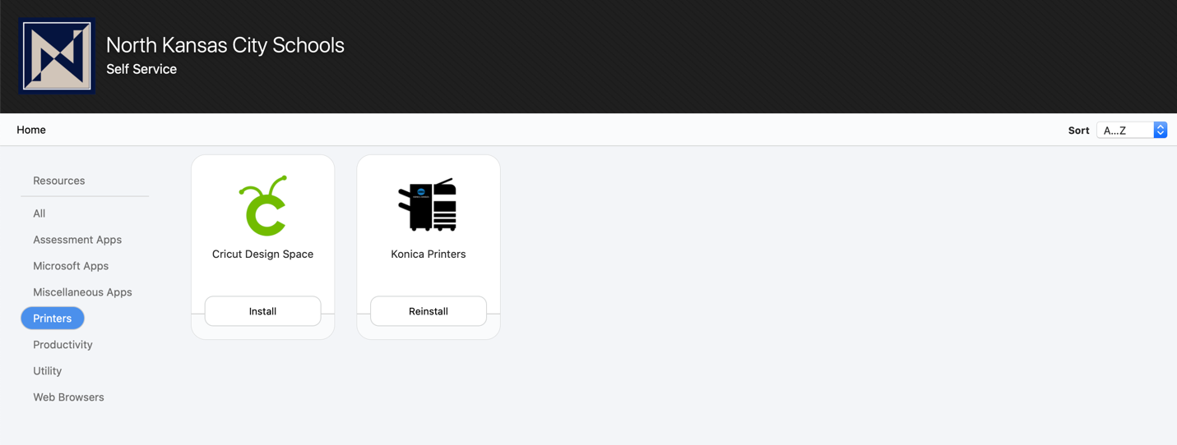

Student Links
- Many of the links students will be using for classes are located on the Student Links page. These links do not have to be downloaded, as they are web-based. Students may want to bookmark or favorite the Student Links page.
- In high school courses students will use:
  - Canvas-online learning platform for all classes. Students will interact with teachers, turn in assignments, and receive feedback.
  - Destiny-online database of all books and databases available in the NKCSD district
  - Box-sign into this web version before downloading the Box app in self-service.
  - Powerschool-students can check grades in their classes on this web-based system.

Other websites that students will find useful
- MCPL-Mid Continent Public Library
  - With their NKC/MCPL Library Card students have access to 24/7 live tutoring, ebooks, audiobooks, print books with curbside service, databases, magazines, and so much more and it’s all FREE!
    - Video on how to set up NKC/MCPL Library Account
- OPHS LMC Webpage-the Oak Park Library website. We will be providing curbside service to our virtual students on Wednesday! Contact angela.vanbatavia@nkcschools.org for more information!

Helpful Videos
- Accessibility features for the Mac
- Canvas for students
- Canvas for parents
- How to sign up as an observer for your child’s Canvas Course

